TECHNICAL REPORT FOR DATA ANALYSIS ROOMPAL

1. Outline
Purpose:
This outline provides a structured roadmap of the report, guiding the reader through each stage of the analysis. It offers a concise preview of the report’s organization, ensuring clarity, logical flow, and ease of navigation.
Report Structure:
- Introduction
- Story of Data
- Data Splitting and Preprocessing
- Pre-Analysis
- In-Analysis
- Post-Analysis and Insights
- Data Visualizations & Charts
- Recommendations and Observations
- Conclusion
- References & Appendices

2. Introduction

2.1 Purpose of the Study
This project presents a structured data analysis of responses collected from the Apartment, House-Sharing, and Roommate Experience Survey (Nigeria). The primary purpose of the study is to transform raw survey responses into meaningful insights that describe respondents’ demographic characteristics, current living situations, housing experiences, and interactions with shared housing and digital housing platforms.
Using Microsoft Excel as the analytical tool, the project focuses on organizing, summarizing, and visualizing survey data in a manner that supports evidence-based understanding of housing patterns and challenges among respondents. This section establishes the foundation for the subsequent analysis by outlining the project’s context, analytical intent, and methodological approach.

2.2 Objective of the Project
The core objective of this project is to analyze and interpret housing-related survey data in order to:
- Examine the demographic profile of respondents, including age group, gender, employment status, and geographic location (state and country).
- Assess respondents’ current living arrangements, such as living alone, living with family, or participating in shared housing.
- Understand respondents’ rental and shared housing experiences, including length of stay in their current city, prior rental history, and exposure to shared housing environments.
- Evaluate housing search experiences and stress levels, as well as the methods used to find roommates or housing.
- Analyze perceptions, trust factors, and usage patterns related to digital housing and apartment-finding platforms.
Overall, the project aims to convert survey responses into clear, actionable insights that reflect real-world housing dynamics and user behavior, using Excel-based analytical techniques.

2.3 Problem Being Addressed
Despite the growing relevance of shared housing and digital apartment-finding platforms, there is limited structured analysis that clearly explains:
- Who is participating in shared or rental housing arrangements,
- What living arrangements are most common among different demographic groups,
- The challenges respondents face during housing searches,
- And the level of trust and adoption of digital housing solutions.
The problem this analysis addresses is the lack of organized, data-driven insight into housing experiences and preferences, which makes it difficult for stakeholders such as researchers, housing advocates, and digital platform developers to understand user needs and pain points.
This project seeks to answer key questions such as:
- What demographic groups are most represented in shared or rental housing?
- How do employment status and location influence living arrangements?
- What factors influence trust and willingness to use verified housing applications?
- What improvements do users suggest for digital housing platforms?

2.4 Key Datasets and Methodologies

Datasets Used
The analysis is based entirely on the results of the primary survey conducted by the team “Apartment, House-Sharing & Roommate Experience Survey”, which contains the following relevant worksheets:
- Raw File – Original unprocessed survey responses.
- Clean Data – Structured and standardized dataset used for all analysis and visualizations.
- Data Dictionary – Documentation explaining the meaning of each variable and response category.
The Clean Data sheet serves as the primary dataset for analysis and includes variables such as:
- Respondent_ID
- Age_Group
- Gender
- State and Country
- Employment_Status
- Current_Living_Arrangement
- Length_of_Stay_In_Current_City
- Ever_Rented_Or_Shared_Housing
- Housing search stress indicators
- Shared housing experiences and concerns
- Usage and trust factors related to digital housing platforms
No external datasets were introduced, ensuring full consistency and integrity of the analysis.

Methodologies Employed (Microsoft Excel)
The analysis was conducted exclusively in Microsoft Excel, using the following techniques:
- Data Cleaning and Validation
Ensuring consistency in categorical variables and handling missing or blank responses.
- Pivot Tables
Used extensively to summarize survey responses by demographic categories, living arrangements, housing experiences, and platform usage patterns.
- Pivot Charts and Visualizations
Bar charts, column charts, and percentage-based visuals were created to clearly communicate trends and distributions across key variables.
- Descriptive Analysis
Frequency counts and proportional breakdowns were applied to interpret respondent behavior and preferences without predictive modeling.
These methodologies were selected to maintain transparency, reproducibility, and clarity, while aligning strictly with the structure and limitations of the dataset.

3. Story of the Data

3.1 Purpose of the Data
The dataset used in this project captures first-hand responses from individuals regarding their demographic characteristics, current living situations, housing experiences, and interactions with shared housing and digital housing platforms in Nigeria. The data serves as the foundational input for understanding housing behaviors, challenges, and preferences, and it informs all analytical outputs generated in this project.
This section narrates the origin of the data, how it was collected, how it is structured, and how it progressed from raw responses to an analysis-ready dataset.

3.2 Data Source
The data originates from a primary survey titled:
“Apartment, House-Sharing & Roommate Experience Survey”
This is primary data, not extracted from an external public repository or third-party database. It was collected directly from respondents and compiled internally into an Excel workbook titled Final Dataset.xlsx. As such, the dataset reflects real user-reported experiences rather than inferred or system-generated data.

3.3 Data Collection Process
Data was collected using a structured survey instrument, where respondents provided answers to predefined questions covering multiple thematic areas, including:
- Demographics
- Current living arrangements
- Rental and shared housing experience
- Housing search stress and challenges
- Use and perception of digital housing platforms
The survey responses were gathered digitally and later exported into Excel format. No automated scripts or system logs were involved in the collection process; instead, the data reflects self-reported responses, which were subsequently compiled into a single dataset.
Following collection, the raw responses were transferred into Excel, where they underwent manual cleaning and standardization, resulting in the creation of separate worksheets:
- a Raw File containing unprocessed responses, and
- a Clean Data sheet used for all analytical tasks.

3.4 Data Structure
The finalized dataset is organized in a tabular structure, where:
- Each row represents a single survey respondent
- Each column represents a specific survey variable
Key structural characteristics include:
- A Respondent_ID column that uniquely identifies each participant
- Categorical variables stored as clearly labeled text responses
- Consistent column naming aligned with the survey questions
The dataset is cross-sectional in nature, meaning all responses were collected at a single point in time rather than over a period. This structure supports descriptive and comparative analysis across demographic groups and housing-related variables.

3.5 Important Features and Their Significance
Several variables within the dataset are particularly critical to the analysis:
- Demographic Variables
Variables such as Age_Group, Gender, Employment_Status, State, and Country provide context for interpreting housing behaviors and enable segmentation of respondents into meaningful groups.
- Current Living Arrangement
This variable identifies whether respondents live alone, with family, or in shared housing, forming the backbone of the living situation analysis.
- Length of Stay in Current City
This feature helps distinguish between long-term residents and more mobile populations, which is important for understanding housing stability and rental patterns.
- Rental and Shared Housing Experience Indicators
Variables indicating whether respondents have rented or shared housing before help assess exposure to and familiarity with shared living environments.
- Housing Search Stress and Challenges
These variables capture respondents’ emotional and practical experiences during housing searches, highlighting pain points in the housing ecosystem.
- Digital Housing Platform Usage and Trust Factors
Variables related to awareness, usage, verification preferences, and trust in housing platforms are essential for evaluating adoption barriers and user expectations.
Together, these features enable a comprehensive analysis of who the respondents are, how they live, the challenges they face, and how they interact with modern housing solutions.

3.6 Data Limitations and Potential Biases
While the dataset is well-structured and suitable for descriptive analysis, certain limitations must be acknowledged:
- Self-Reported Bias
Because responses are self-reported, they may be influenced by personal perception, memory recall, or social desirability.
- Sample Representation
The dataset represents only individuals who chose to participate in the survey. As such, findings may not be fully generalizable to the entire Nigerian population.
- Categorical Constraints
Many variables are categorical, which limits the ability to perform advanced numerical or predictive analysis.
- Missing or Skipped Responses
Some respondents may have skipped certain questions, leading to missing values that can slightly affect frequency distributions.
These limitations were considered during analysis, and all conclusions drawn are framed within the descriptive scope of the available data.

4. Data Splitting and Preprocessing

4.1 Purpose of Data Preprocessing
Data preprocessing was carried out to ensure that the survey dataset was accurate, consistent, and analysis-ready before any summaries or visualizations were produced. Given that the data originated from self-reported survey responses, careful preparation was necessary to minimize inconsistencies, improve reliability, and support meaningful Excel-based analysis using pivot tables and charts.

4.2 Data Cleaning
Several structured cleaning steps were applied within Microsoft Excel to improve data quality:
- Removal of Duplicates
The dataset was reviewed for duplicate records using the Respondent_ID field. Where duplicate entries were identified, only a single, valid response was retained to avoid double counting.
- Standardization of Categorical Responses
Categorical fields such as Gender, Employment_Status, Current_Living_Arrangement, and platform-related responses were checked for spelling inconsistencies, capitalization differences, and formatting issues. These were corrected to ensure uniform categories across the dataset.
- Column Validation and Alignment
Column headers were validated against the Data Dictionary to confirm that all variables were correctly named and accurately represented their survey questions.
These cleaning steps resulted in a structured Clean Data worksheet that served as the sole source for analysis.

4.3 Handling Missing Values
Missing or blank responses were handled using a controlled and non-invasive approach, consistent with descriptive survey analysis:
- Preservation of Missing Entries
Blank cells were not artificially filled with assumed values, as this could distort respondents’ true experiences.
- Exclusion at Analysis Level
When generating pivot tables and charts, Excel’s default behavior was used to exclude missing values from specific calculations while preserving the overall dataset.
- Categorical Transparency
In cases where missing responses were analytically relevant, they were grouped under blank or “Not specified” categories to maintain transparency.
This approach ensured that the analysis remained faithful to the original responses while avoiding misleading imputations.

4.4 Data Transformations
Only minimal and necessary transformations were applied, in line with the nature of the dataset:
- Creation of Grouped Summaries
Pivot tables were used to aggregate responses by age group, employment status, living arrangement, and location without altering the original data.
- Derived Counts and Percentages
Excel calculations were used to express frequency distributions as percentages, improving interpretability in charts and dashboards.
- No Numerical Normalization or Scaling
Since the dataset is predominantly categorical, advanced transformations such as normalization or standardization were not applicable and were intentionally avoided.
No synthetic variables or predictive metrics were introduced, preserving the integrity of the original survey design.

4.5 Data Splitting
Rather than traditional machine-learning-based splitting, the dataset was logically segmented to support targeted analysis:
- Independent Variables
Demographic and contextual variables such as Age_Group, Gender, Employment_Status, State, and Length_of_Stay_In_Current_City were treated as explanatory variables.
- Dependent / Outcome Variables
Variables related to Current_Living_Arrangement, Housing Search Stress, Shared Housing Experience, and Digital Platform Usage and Trust were analyzed as outcome indicators.
This logical separation allowed the analysis to explore how demographic and contextual factors relate to housing experiences and platform perceptions, without introducing unsupported predictive claims.

4.6 Industry Context
The dataset belongs to the Housing and Real Estate Technology (PropTech) industry, with strong relevance to:
- Rental housing markets
- Shared accommodation ecosystems
- Digital housing and apartment-finding platforms
The data reflects user behavior, challenges, and trust dynamics within modern housing systems, particularly in an urban Nigerian context.

4.7 Stakeholders
The findings from this analysis are valuable to multiple stakeholder groups, including:
- Housing Platform Developers and Product Teams
To improve platform features, verification systems, and user trust mechanisms.
- Real Estate and Property Managers
To better understand renter profiles and shared housing preferences.
- Policy Analysts and Housing Advocates
To identify stress points and barriers in housing access.
- Business Strategists and Decision-Makers
To guide data-driven decisions around market positioning and user engagement.

4.8 Value to the Industry
This analysis delivers meaningful value by:
- Providing evidence-based insights into how individuals experience housing and shared living arrangements.
- Identifying key friction points in housing searches and platform trust.
- Supporting the design of user-centric housing solutions grounded in real survey data.
- Enabling stakeholders to make informed strategic, operational, and product decisions.
By converting raw survey data into structured insights, the project contributes to a deeper understanding of housing dynamics and supports continuous improvement within the housing and PropTech ecosystem.

5. Pre-Analysis Board

5.1 Purpose of the Pre-Analysis
The Pre-Analysis Board establishes preliminary patterns, expectations, and analytical direction derived from an initial review of the cleaned survey dataset. At this stage, the goal is not to confirm conclusions but to identify emerging trends, potential relationships, and key questions that will guide the construction and interpretation of the dashboards.
Given that a single dataset underpins multiple dashboards, this pre-analysis serves as a unified analytical blueprint, ensuring consistency, coherence, and intent across all subsequent visual analyses.

5.2 Demographics & Living Situation (Foundational Context)

Identify Key Trends
Initial inspection of the data suggests that:
- The respondent population is dominated by working-age individuals, with notable representation among students and early-career professionals.
- Urban residency appears prevalent, indicating a dataset skewed toward individuals more likely to engage in rental or shared housing arrangements.
- Living arrangements vary across demographic segments, with indications that employment status and age group influence whether respondents live alone, with family, or in shared housing.

Potential Correlations
- A potential relationship exists between employment status and current living arrangement, where students and early-career respondents appear more inclined toward shared housing.
- Length of stay in the current city may correlate with housing stability, influencing the likelihood of living independently versus sharing accommodation.

Initial Insights
These observations position demographics and living situation as key explanatory variables for interpreting all other dashboards. Understanding who the respondents are and how they live is essential before analyzing experiences, risks, or perceptions.

5.3 Housing Search Experience Dashboard

Identify Key Trends
Preliminary patterns indicate that:
- A significant portion of respondents report moderate to high levels of stress during housing searches.
- Housing search challenges appear to be common regardless of prior rental experience, suggesting systemic issues rather than isolated cases.

Potential Correlations
- There may be a relationship between current living arrangement and housing search stress, with individuals seeking shared housing potentially facing different challenges compared to those searching for solo rentals.
- Respondents newer to a city may experience higher levels of housing-related stress compared to long-term residents.

Initial Insights
These early signals suggest that housing search difficulty is a central pain point, warranting deeper exploration into the factors driving stress, inefficiency, and dissatisfaction within the housing ecosystem.

5.4 Roommate & Shared Housing Dashboard

Identify Key Trends
Initial data review suggests that:
- A considerable number of respondents have prior experience with shared housing or roommates.
- Common concerns emerge around compatibility, reliability, and shared responsibilities.

Potential Correlations
- Demographic factors such as age group and employment status may influence attitudes toward shared housing.
- Individuals with previous shared housing experience may exhibit stronger opinions, both positive and negative about roommate arrangements.

Initial Insights
Shared housing is not merely a temporary solution but a significant housing model for many respondents. Understanding its benefits and challenges is critical for interpreting satisfaction levels and future housing preferences.

5.5 Fraud, Trust & Security Dashboard

Identify Key Trends
Early observations indicate that:
- Trust and security concerns are highly salient among respondents engaging with housing searches or digital platforms.
- Verification of listings and users appears to be a recurring theme in respondents’ preferences.

Potential Correlations
- Housing search stress may be linked to fear of fraud or misinformation, especially when dealing with unfamiliar landlords or roommates.
- Willingness to use digital housing platforms may correlate with the presence (or absence) of strong trust and verification mechanisms.

Initial Insights
Trust emerges as a critical barrier to adoption of digital housing solutions. These insights suggest that security-related features may significantly influence user behavior and platform credibility.

5.6 Open-Ended Response Analysis

Identify Key Trends
Preliminary review of open-ended responses reveals:
- Recurring themes around affordability, trust, safety, and communication.
- Emotional language that reinforces the quantitative findings related to stress and uncertainty.

Potential Correlations
- Qualitative responses appear to contextualize numerical patterns observed in housing stress and trust-related variables.
- Respondents who express dissatisfaction in structured questions often provide detailed explanations in open-ended fields.

Initial Insights
The open-ended responses serve as qualitative validation of the structured data, adding depth, nuance, and real-world context. They are expected to clarify why certain patterns appear in the dashboards, not just what those patterns are.

5.7 Pre-Analysis Summary
At the pre-analysis stage, the data suggests that:
- Demographics and living situations shape housing experiences.
- Housing searches are frequently stressful and complex.
- Shared housing is widespread but accompanied by notable concerns.
- Trust and security significantly influence platform usage and decision-making.
- Open-ended responses reinforce and humanize quantitative findings.
These preliminary insights provide a clear analytical direction, ensuring that the dashboards are not exploratory by chance, but purpose-driven and aligned with defined questions and expectations.

6. In-Analysis

6.1 Purpose of the In-Analysis
This section represents the core analytical interpretation of the project. It moves beyond data preparation and preliminary expectations to examine patterns, relationships, and emerging insights observed across the dashboards. At this stage, the focus is on identifying unconfirmed insights, exploring possible correlations, and translating early findings into practical, evidence-informed recommendations, using Microsoft Excel as the primary analytical tool.

6.2 Unconfirmed Insights
Based on the dashboard-level analysis, several notable patterns and potential relationships emerge. While these insights are not statistically validated, they provide strong analytical direction:
- Demographic Influence on Living Arrangements
Early patterns suggest that age group and employment status influence whether respondents live independently, with family, or in shared housing. Younger respondents and students appear more inclined toward shared accommodation, potentially driven by affordability and flexibility considerations.
- Housing Search Stress and Experience Level
Housing search stress appears widespread, even among respondents with prior rental or shared housing experience. This suggests that stress may be linked more to systemic housing challenges than to individual inexperience.
- Shared Housing and Trust Concerns
Respondents with shared housing experience frequently express concerns around compatibility, reliability, and accountability. This indicates a possible relationship between shared living arrangements and heightened sensitivity to trust-related issues.
- Trust, Fraud, and Platform Adoption
A recurring pattern shows that fear of fraud and lack of verification mechanisms may reduce willingness to use digital housing platforms. Trust appears to be a central factor influencing both housing search behavior and platform engagement.
- Qualitative Reinforcement from Open-Ended Responses
Open-ended responses consistently reference affordability, safety, and trust, reinforcing trends observed in structured survey variables and suggesting alignment between quantitative patterns and lived experiences.
These insights serve as hypotheses rather than conclusions and guide the formulation of early recommendations.

6.3 Preliminary Recommendations
Based on the unconfirmed insights observed, the following preliminary recommendations are proposed:
- Enhance Trust and Verification Mechanisms
Digital housing platforms should prioritize verified listings, identity checks, and transparent reporting systems to address fraud concerns and improve user confidence.
- User Segmentation by Demographics
Housing solutions and platform features should be tailored based on demographic profiles, particularly age group and employment status, to better align with user needs and living preferences.
- Improve Housing Search Transparency
Clearer information on pricing, location, roommate expectations, and housing conditions may help reduce search-related stress.
- Support Shared Housing Compatibility
Platforms facilitating shared housing should incorporate matching criteria and communication tools to improve roommate compatibility and manage expectations.
- Leverage Qualitative Feedback
Open-ended responses should be used alongside quantitative metrics to inform platform design, policy decisions, and user engagement strategies.
These recommendations remain exploratory and are intended to inform further validation and decision-making rather than serve as final prescriptions.

6.4 Analysis Techniques Used in Excel
All analyses in this project were conducted using Microsoft Excel, leveraging the following tools and techniques:
- Pivot Tables
Used extensively to summarize and segment survey responses by demographics, living arrangements, housing experiences, and platform-related variables.
- Pivot Charts
Bar charts and column charts were generated from pivot tables to visualize distributions and compare patterns across categories.
- Filtering and Sorting
Excel filters were applied to isolate specific respondent groups, such as shared housing participants or platform users.
- Basic Excel Functions
Functions such as COUNT, COUNTA, and percentage calculations were used to compute frequency distributions and proportional insights.
- Data Validation Against the Data Dictionary
Column definitions were cross-checked to ensure analytical accuracy and consistency.
Advanced statistical modeling or predictive techniques were not applied, as the dataset is primarily categorical and designed for descriptive and exploratory analysis.

6.5 In-Analysis Summary
The in-analysis phase reveals that housing experiences within the dataset are shaped by demographics, market challenges, shared living dynamics, and trust considerations. While the insights identified require further validation, they provide a strong analytical foundation for understanding user behavior and informing housing-related decisions.
This section bridges the gap between preliminary expectations and final conclusions, ensuring that subsequent insights and recommendations are grounded in observed data patterns.

7. Post-Analysis and Insights

7.1 Purpose of the Post-Analysis
The purpose of this section is to consolidate and evaluate the conclusions drawn from the complete analysis, assessing whether the initial assumptions and exploratory insights identified during the pre-analysis and in-analysis stages were supported by the data. This section confirms validated patterns, highlights key findings across all dashboards, and reflects on how final insights align with or diverge from initial expectations.

7.2 Key Findings

Demographics & Living Situation
The analysis confirms that demographic characteristics significantly influence living arrangements. Age group and employment status emerged as strong determinants of whether respondents live independently, with family, or in shared housing. Younger respondents and students are more likely to engage in shared housing, while respondents with stable employment show a higher preference for independent living. These patterns validate the assumption that housing choices are closely tied to life stage and economic stability.

Housing Search Experience
Findings confirm that housing search stress is widespread and persistent across respondent groups. Contrary to the expectation that experience reduces difficulty, the analysis shows that even respondents with prior rental or shared housing experience continue to face significant stress. This suggests that housing search challenges are systemic in nature, driven by market constraints, information gaps, and trust concerns rather than individual inexperience.

Roommate & Shared Housing
The analysis validates that shared housing is a commonly adopted but highly nuanced living arrangement. While shared housing provides affordability and accessibility benefits, it is also associated with concerns around compatibility, reliability, and shared responsibilities. Respondents with prior shared housing experience exhibit stronger and more defined opinions, confirming that lived experience plays a critical role in shaping attitudes toward shared accommodation.

Fraud, Trust & Security
One of the strongest confirmed findings is the central role of trust and security in housing decisions. The analysis validates the initial hypothesis that fear of fraud significantly affects both housing search behavior and the willingness to use digital housing platforms. Respondents consistently favor verified listings, identity checks, and platform accountability, confirming that trust mechanisms are not supplementary features but foundational requirements.

Open-Ended Response Analysis
Qualitative responses strongly reinforce the quantitative findings. Recurring themes such as affordability, safety, trust, and communication—mirror patterns observed across all dashboards. The alignment between open-ended responses and structured data strengthens the credibility of the findings and confirms that the numerical trends accurately reflect real-world experiences.

7.3 Comparison with Initial Findings
The final analysis largely validates the expectations outlined in the Pre-Analysis Board, with several important refinements:
- The assumption that demographics influence housing choices was confirmed, with clear patterns across age and employment categories.
- The expectation that housing search stress would primarily affect inexperienced renters was challenged; stress proved to be widespread and persistent regardless of prior experience.
- Anticipated trust concerns around digital housing platforms were strongly validated, emerging as one of the most influential factors in user behavior.
- Shared housing was initially viewed as primarily affordability-driven; the analysis revealed deeper complexity, including emotional, interpersonal, and trust-related dimensions.
- Open-ended responses exceeded expectations in their consistency and alignment with quantitative results, providing strong qualitative validation.
No major contradictions were identified; however, the persistence of housing search stress across experience levels was a notable and somewhat counter-intuitive insight.

7.4 Post-Analysis Summary
In summary, the post-analysis confirms that housing experiences within the dataset are shaped by an interconnected set of factors: demographics, systemic housing challenges, shared living dynamics, and trust considerations. The findings demonstrate that effective housing solutions, particularly digital platforms must address not only affordability and access, but also verification, transparency, and user protection.
By integrating quantitative and qualitative insights, this analysis provides a well-rounded understanding of respondent behavior and establishes a strong evidence base for the final recommendations presented in this report.

8. Data Visualizations & Charts

8.2 Demographics & Current Living Situation Dashboard
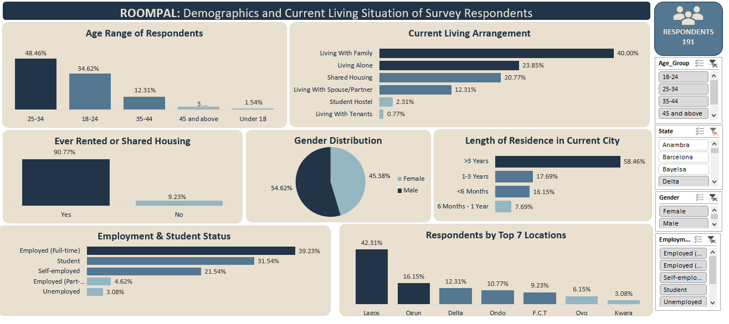

Purpose of This Dashboard
The Demographics & Current Living Situation dashboard provides foundational context for the entire analysis by visually summarizing who the respondents are and how they currently live. These visualizations establish the baseline characteristics that influence housing behavior, search experiences, trust perceptions, and shared housing decisions examined in subsequent dashboards.

8.2.1 Overview of Visualizations Included
This dashboard consolidates multiple Excel-based visualizations derived from the Clean Data worksheet and structured according to the Data Dictionary. The charts focus on:
- Age distribution
- Gender distribution
- Employment and student status
- Geographic concentration of respondents
- Current living arrangements
- Length of residence in current location
- Prior rental or shared housing experience
Each visualization is presented on its own dedicated worksheet and collectively forms a unified demographic narrative.

8.2.2 Explanation of Individual Visualizations and Key Takeaways

Age Range of Respondents
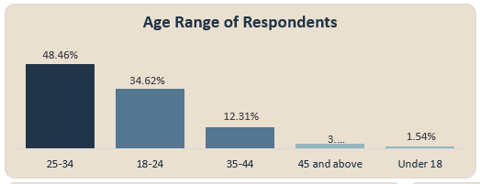
Chart Focus: Distribution of respondents across predefined age categories.
What the Chart Shows:
The age distribution chart highlights that the dataset is dominated by working-age individuals, particularly younger and early-career respondents.
Key Takeaway:
This age concentration explains the prominence of rental and shared housing experiences observed across the analysis and reinforces the relevance of affordability, flexibility, and mobility as central housing themes.

Gender Distribution
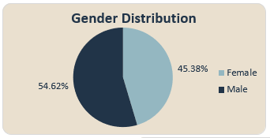
Chart Focus: Breakdown of respondents by gender.
What the Chart Shows:
The visualization presents a clear gender composition of survey participants, offering balance and representation without dominance by a single gender group.
Key Takeaway:
This balanced distribution strengthens the general interpretability of housing preferences and experiences across genders and reduces the likelihood of gender-driven response bias.

Employment & Student Status
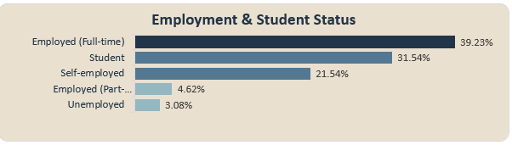
Chart Focus: Respondents categorized by employment and student status.
What the Chart Shows:
A significant proportion of respondents fall within student and employed categories, with fewer respondents in transitional or undefined statuses.
Key Takeaway:
Employment and student status emerge as critical explanatory variables, helping to contextualize preferences for shared housing, sensitivity to housing costs, and tolerance for housing instability.

Respondents by Top 7 Locations
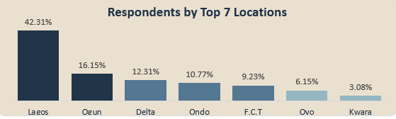
Chart Focus: Geographic distribution of respondents by location.
What the Chart Shows:
The chart identifies a concentration of respondents in a limited number of key locations, likely reflecting urban or high-demand housing markets.
Key Takeaway:
This geographic clustering supports earlier findings that housing stress and shared living arrangements may be more pronounced in urbanized areas where competition, pricing pressure, and demand are higher.

Current Living Arrangement
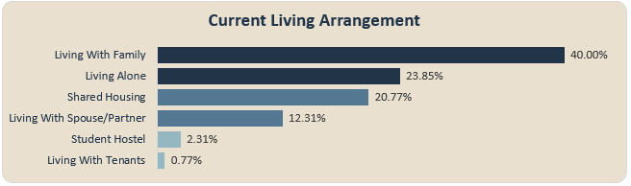
Chart Focus: Distribution of respondents by living arrangement type.
What the Chart Shows:
Respondents are distributed across living alone, living with family, and shared housing arrangements.
Key Takeaway:
The presence of a substantial shared housing segment confirms that shared accommodation is not marginal but a mainstream housing option within the respondent population, justifying its dedicated analytical focus in later dashboards.

Length of Residence in Current Location
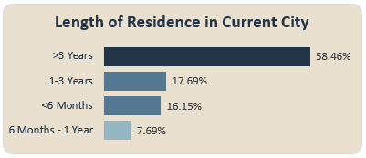
Chart Focus: Duration respondents have lived in their current city or location.
What the Chart Shows:
The chart distinguishes between newer residents and long-term residents.
Key Takeaway:
Length of residence provides insight into housing stability and mobility, helping explain differences in housing familiarity, search stress, and openness to shared housing or platform-based solutions.

Ever Rented or Shared Housing
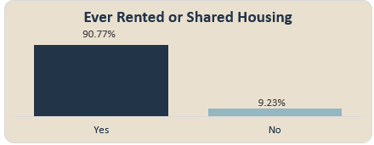
Chart Focus: Prior rental or shared housing experience.
What the Chart Shows:
A large proportion of respondents report having rented or shared housing at some point.
Key Takeaway:
This confirms that the dataset reflects experienced housing participants, lending credibility to opinions expressed regarding housing challenges, trust concerns, and platform expectations.

8.2.3 Dashboard-Level Insights for Stakeholders
When viewed collectively, the Demographics & Current Living Situation dashboard:
- Establishes who the respondents are before deeper behavioral analysis
- Explains why shared housing, trust, and stress themes recur across later dashboards
- Enables stakeholders to segment housing insights by age, employment status, and location
- Provides a factual baseline for interpreting all subsequent analytical findings
This dashboard functions as the contextual anchor of the entire report.

8.2.4 Role of Excel in Visualization Development
All visualizations in this dashboard were developed using Microsoft Excel, primarily leveraging:
- Pivot Tables for categorical aggregation
- Pivot Charts (bar and column charts) for distribution comparison
- Filters and grouping to ensure consistent category definitions
- Data validation using the Data Dictionary to maintain accuracy
No external visualization tools were used, ensuring transparency and reproducibility.

8.2.5 Summary Interpretation
The Demographics & Current Living Situation dashboard confirms that housing behaviors observed throughout the analysis are deeply rooted in respondent demographics, employment status, geographic concentration, and housing experience levels. These visualizations justify the analytical focus of subsequent dashboards and provide essential grounding for interpreting housing stress, shared living dynamics, trust concerns, and qualitative feedback.

8.3 Fraud, Trust & Security Dashboard
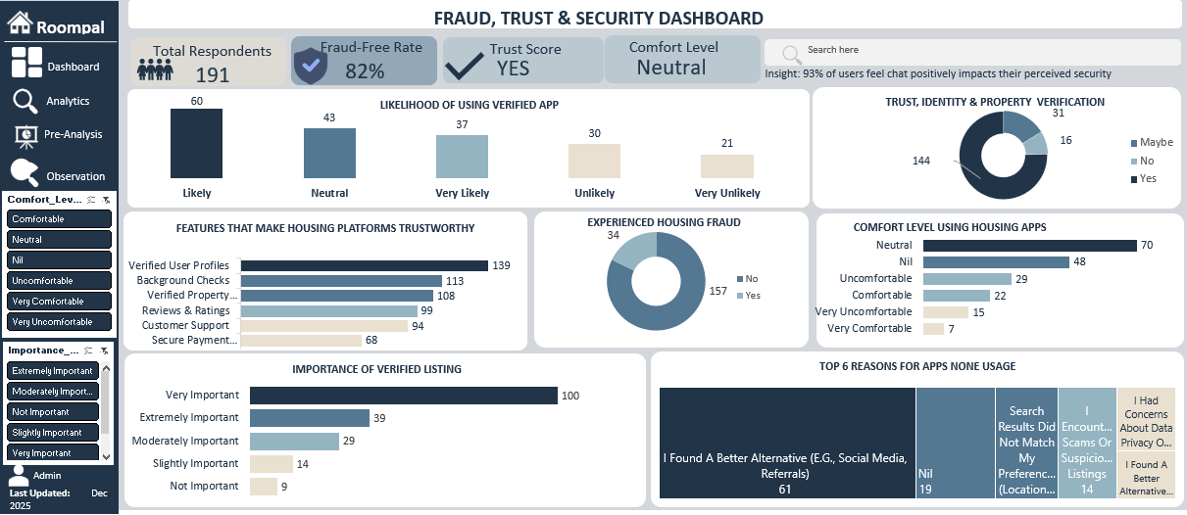

Purpose of This Dashboard
The Fraud, Trust & Security dashboard examines respondents’ experiences with housing-related fraud, their perceptions of trust within housing platforms, and the security features that influence platform usage. This dashboard builds on the demographic foundation established earlier by exploring how trust concerns shape housing search behavior, platform adoption, and willingness to engage in online housing transactions.

8.3.1 Overview of Visualizations Included
This dashboard consolidates multiple Excel-based visualizations derived from the Clean Data worksheet and structured according to the Data Dictionary. The charts focus on:
- Experience with housing-related fraud
- Perceived importance of verified listings
- Likelihood of using platforms with identity and property verification
- Comfort level with online housing transactions
- Reasons for avoiding housing platforms
- Platform features that increase user trust
Each visualization is presented on its own dedicated worksheet and collectively forms a coherent narrative around trust, risk exposure, and security expectations within the housing search process.

8.3.2 Explanation of Individual Visualizations and Key Takeaways

Experience with Housing Fraud
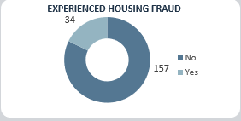
Chart Focus: Respondents’ reported experience with housing-related fraud.
What the Chart Shows:
The visualization highlights that a meaningful proportion of respondents have encountered fraudulent housing listings or transactions during their housing search.
Key Takeaway:
The prevalence of fraud experience establishes trust as a central analytical theme and justifies the emphasis on security, verification, and platform accountability throughout the report.

Importance of Verified Listings
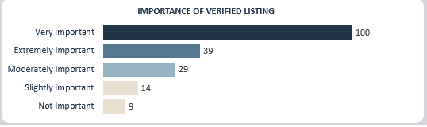
Chart Focus: Perceived importance of property and identity verification on housing platforms.
What the Chart Shows:
Most respondents rate verified listings as highly important when evaluating housing platforms.
Key Takeaway:
Verification emerges as a foundational trust signal, indicating that users associate verified listings with reduced fraud risk and improved decision confidence.

Likelihood of Using Platforms with Verification Features
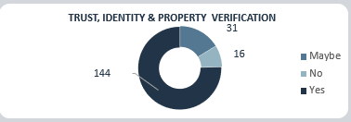
Chart Focus: Respondents’ likelihood of using platforms that offer identity and property verification.
What the Chart Shows:
The chart shows a strong inclination toward platforms that incorporate verification mechanisms.
Key Takeaway:
Trust-enhancing features directly influence platform adoption, suggesting that security investments have tangible effects on user engagement.

Comfort Level with Online Housing Transactions
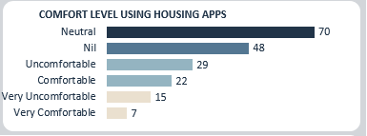
Chart Focus: Respondents’ comfort levels when engaging in online housing searches and transactions.
What the Chart Shows:
Comfort levels vary across respondents, with reduced comfort often aligned with concerns around fraud and misinformation.
Key Takeaway:
Lower comfort levels signal trust gaps that may limit platform usage, reinforcing the need for visible security and transparency measures.

Reasons for Avoiding Housing Platforms
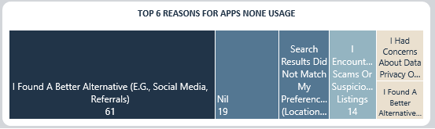
Chart Focus: Primary reasons respondents choose not to use housing platforms.
What the Chart Shows:
Fraud concerns, lack of trust, and fear of scams are prominent reasons for non-usage.
Key Takeaway:
Trust-related barriers outweigh usability or accessibility issues, positioning security as a prerequisite for platform adoption rather than an optional enhancement.

Features That Increase Trust in Housing Platforms
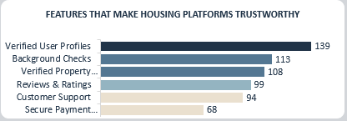
Chart Focus: Platform features ranked by their impact on user trust.
What the Chart Shows:
Verification features, secure communication channels, and transparent user profiles rank highest in trust enhancement.
Key Takeaway:
Trust is built through a combination of identity assurance, accountability, and platform transparency rather than through a single isolated feature.

8.3.3 Dashboard-Level Insights for Stakeholders
When viewed collectively, the Fraud, Trust & Security dashboard:
- Demonstrates the widespread impact of fraud on housing search behavior
- Explains variations in comfort, adoption, and platform usage
- Highlights verification and transparency as critical trust drivers
- Provides evidence-based guidance for trust-focused platform design
This dashboard connects user experience with actionable platform requirements.

8.3.4 Role of Excel in Visualization Development
All visualizations in this dashboard were developed using Microsoft Excel, primarily leveraging:
- Pivot Tables for categorical aggregation
- Pivot Charts (bar and column charts) for distribution comparison
- Consistent category mapping guided by the Data Dictionary
- Filters and validation checks to ensure analytical accuracy
No external visualization tools were used, ensuring transparency, consistency, and reproducibility.

8.3.5 Summary Interpretation
The Fraud, Trust & Security dashboard reveals that trust concerns are a dominant force shaping housing platform behavior. Respondents’ lived experiences with fraud significantly influence comfort levels, adoption decisions, and expectations of platform responsibility. These visualizations reinforce the conclusion that verification, transparency, and security are essential, not optional components of effective housing platforms.

8.4 Housing Search Experience Dashboard
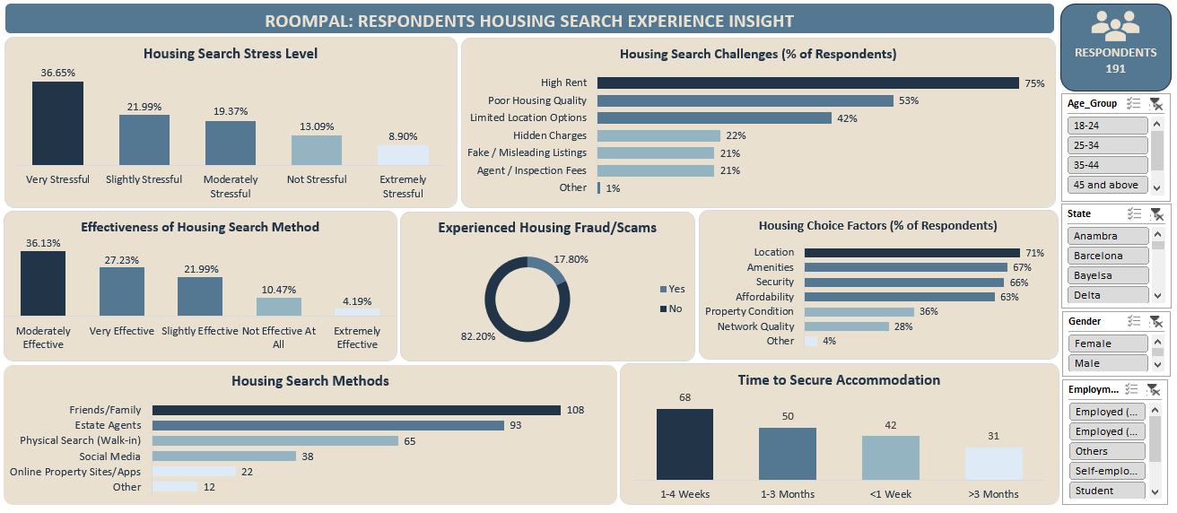

Purpose of This Dashboard
The Housing Search Experience dashboard examines how respondents search for housing, the effectiveness of different search methods, the challenges encountered, and the emotional and temporal costs associated with securing accommodation. This dashboard provides a behavioral lens into the housing search process, highlighting inefficiencies, stress factors, and decision drivers that shape overall housing outcomes.

8.4.1 Overview of Visualizations Included
This dashboard consolidates multiple Excel-based visualizations derived from the Clean Data worksheet and structured according to the Data Dictionary. The charts focus on:
- Primary housing search methods used by respondents
- Perceived effectiveness of different search channels
- Time taken to secure housing
- Key factors influencing housing choice decisions
- Common challenges encountered during housing search
- Experience with fraud during housing search
- Reported stress levels associated with housing search
Each visualization is presented on its own dedicated worksheet and collectively forms a comprehensive narrative of the housing search journey from initiation to outcome.

8.4.2 Explanation of Individual Visualizations and Key Takeaways

Housing Search Methods
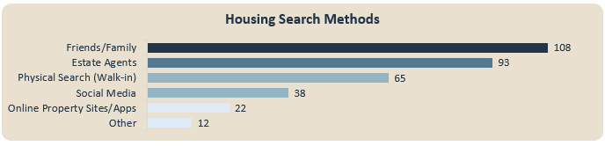
Chart Focus: Primary methods used by respondents to search for housing.
What the Chart Shows:
The chart illustrates the distribution of housing search channels, including online platforms, personal networks, agents, and informal methods.
Key Takeaway:
The prominence of informal and platform-based search methods highlights the fragmented nature of housing search processes and underscores the importance of trust and reliability across both formal and informal channels.

Search Effectiveness
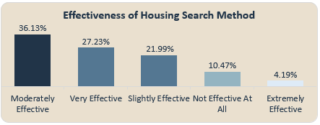
Chart Focus: Respondents’ perceived effectiveness of different housing search methods.
What the Chart Shows:
The visualization compares how effective respondents find each search method in successfully securing housing.
Key Takeaway:
Differences in perceived effectiveness reveal inefficiencies within commonly used channels, suggesting that frequent usage does not always translate into successful outcomes.

Time Taken to Secure Housing
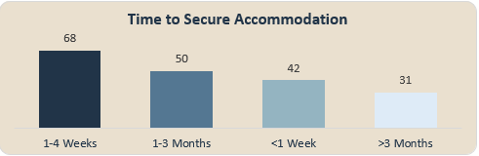
Chart Focus: Duration required by respondents to secure housing.
What the Chart Shows:
The chart categorizes respondents by the length of time spent searching before securing accommodation.
Key Takeaway:
Extended search durations indicate structural challenges within the housing market and contribute directly to search fatigue, stress, and compromised housing decisions.

Housing Choice Factors
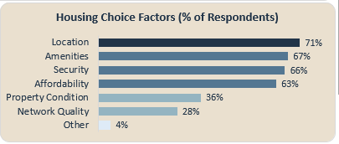
Chart Focus: Factors influencing respondents’ final housing decisions.
What the Chart Shows:
Key decision drivers such as affordability, location, safety, and access to amenities are visually ranked based on respondent importance.
Key Takeaway:
Affordability and location consistently emerge as dominant factors, reinforcing economic and spatial constraints as primary determinants of housing outcomes.

Housing Search Challenges
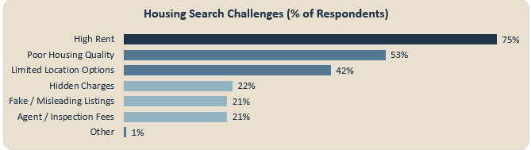
Chart Focus: Common obstacles encountered during housing search.
What the Chart Shows:
The visualization highlights challenges such as high costs, limited availability, unreliable information, and competition.
Key Takeaway:
The concentration of structural and informational challenges indicates that housing difficulty is driven more by systemic market issues than by individual search behavior alone.

Housing Search Fraud Experience
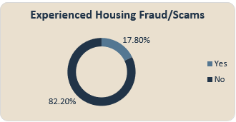
Chart Focus: Respondents’ experience with fraud during housing search.
What the Chart Shows:
The chart shows the proportion of respondents who encountered fraudulent listings or deceptive practices while searching for housing.
Key Takeaway:
The recurrence of fraud within the search process reinforces earlier findings that trust deficits significantly shape housing behavior and platform perceptions.

Housing Search Stress Level
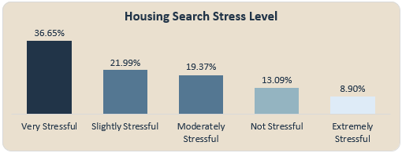
Chart Focus: Self-reported stress levels experienced during housing search.
What the Chart Shows:
Respondents report varying levels of stress, with a significant portion experiencing moderate to high stress during their housing search.
Key Takeaway:
Elevated stress levels reflect the cumulative impact of prolonged search duration, uncertainty, financial pressure, and fraud risk.

8.4.3 Dashboard-Level Insights for Stakeholders
When viewed collectively, the Housing Search Experience dashboard:
- Reveals inefficiencies across commonly used housing search channels
- Highlights time, stress, and fraud as interconnected outcomes
- Demonstrates the emotional and practical cost of housing acquisition
- Provides evidence for the need for more reliable, transparent housing platforms
This dashboard translates individual search experiences into broader market-level insights.

8.4.4 Role of Excel in Visualization Development
All visualizations in this dashboard were developed using Microsoft Excel, primarily leveraging:
- Pivot Tables for aggregating categorical and ordinal survey responses
- Pivot Charts (bar and column charts) for comparative analysis
- Structured grouping aligned with the Data Dictionary
- Dashboard assembly using linked charts for integrated analysis
This approach ensures analytical transparency, consistency, and ease of replication.

8.4.5 Summary Interpretation
The Housing Search Experience dashboard demonstrates that securing housing is often a prolonged, stressful, and risk-prone process. Respondents navigate multiple search channels with varying effectiveness, encounter structural and informational barriers, and experience significant emotional strain. These findings provide critical context for understanding subsequent analyses related to shared housing decisions, trust expectations, and platform feature preferences.

8.5 Roommate & Shared Housing Dashboard
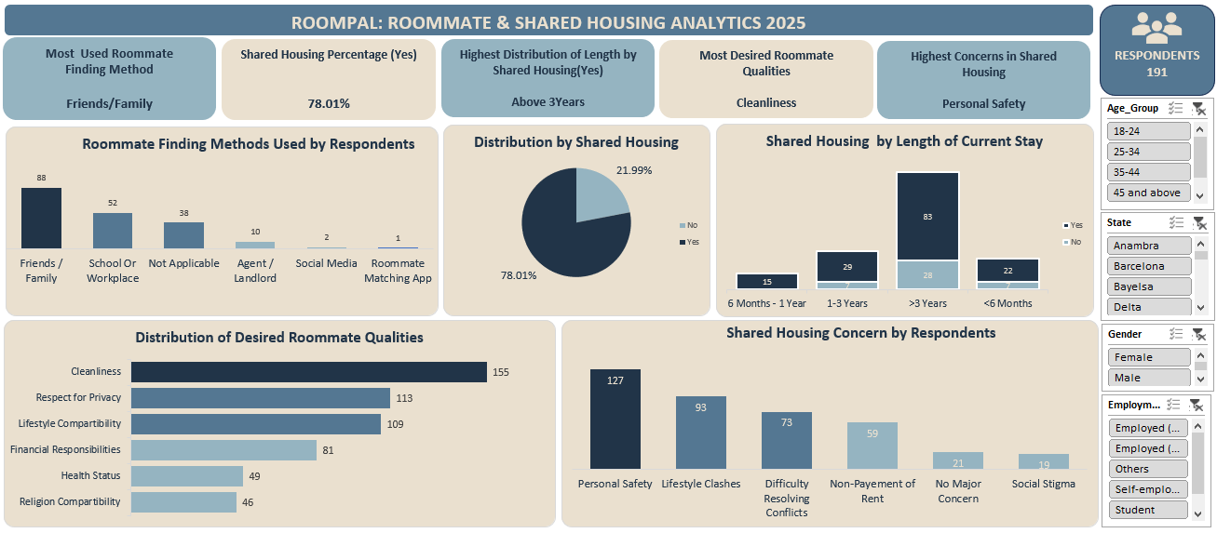

8.5.1 Roommate & Shared Housing Dashboard Overview
The Roommate & Shared Housing Dashboard serves as a centralized visual summary of respondents’ shared housing experiences, preferences, and concerns. It integrates multiple charts into a single view to support efficient interpretation and informed decision-making.
The dashboard focuses on:
- Prior shared housing experience
- Methods used to find roommates
- Desired roommate attributes
- Key concerns associated with shared housing

8.5.2 Charts and Graphs Included

1. Shared Housing Experience (Before)
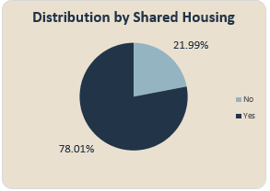
Chart Description:
This chart illustrates whether respondents have previously lived in a shared housing arrangement.
Key Takeaway:
The visualization shows that a substantial portion of respondents have prior experience with shared housing, confirming that shared living is not a niche solution but a common housing pathway. This reinforces the relevance of roommate-focused analysis and the need to improve shared housing systems rather than treating them as temporary alternatives.

2. Roommate Finding Methods
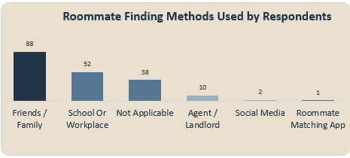
Chart Description:
This chart displays the various methods respondents used to find roommates, such as personal networks, referrals, or informal channels.
Key Takeaway:
The chart highlights a strong reliance on informal and personal networks when sourcing roommates. This suggests a gap in structured, trusted roommate-matching platforms and indicates an opportunity for digital housing solutions to formalize and improve the roommate discovery process.

3. Desired Roommate Qualities
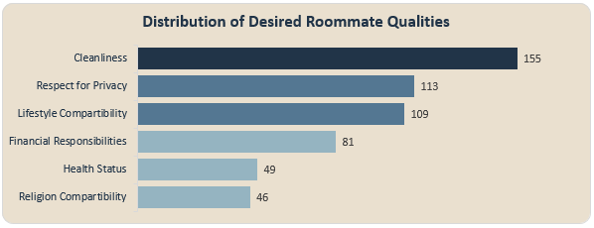
Chart Description:
This visualization captures the most important qualities respondents look for in potential roommates, such as cleanliness, respectfulness, responsibility, and lifestyle compatibility.
Key Takeaway:
The chart clearly shows that behavioral and interpersonal qualities outweigh demographic factors in roommate selection. Compatibility, cleanliness, and mutual respect are prioritized, emphasizing that successful shared housing depends more on shared values and habits than on surface characteristics.

4. Shared Housing Concerns
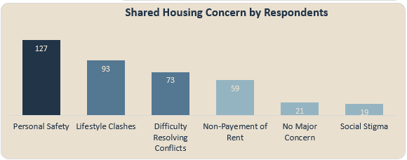
Chart Description:
This chart presents the primary concerns respondents associate with shared housing, including personal safety, lifestyle clashes, trust issues, privacy, and accountability.
Key Takeaway:
The visualization indicates that personal safety and interpersonal risk are dominant concerns in shared housing arrangements. These concerns explain why shared housing, despite its affordability benefits, remains a sensitive and sometimes unstable solution for many users.

5. Shared Housing by Length of Current Stay
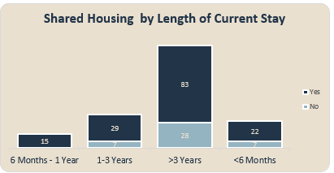
Chart Description:
This chart illustrates the relationship between respondents’ shared housing status and the length of time they have spent in their current living arrangement.
Key Takeaway:
The visualization shows that shared housing is more prevalent among respondents with shorter current stays, while longer stays are less commonly associated with shared housing arrangements. This pattern suggests that shared housing is often a transitional housing solution, particularly for individuals who are new to an area or in temporary living situations.

8.5.3 Dashboard Interpretation for Stakeholders
When viewed collectively, the dashboard communicates three critical messages:
- Shared housing is widely experienced, making it a core housing model rather than an exception.
- The roommate search process is largely informal, exposing users to risk and inefficiency.
- Trust, compatibility, and accountability are the defining success factors in shared housing outcomes.
This dashboard enables stakeholders to quickly identify where interventions, such as verified roommate matching, compatibility filters, and clear shared-living expectations would have the greatest impact.

8.5.4 Summary of Visual Insights
The Roommate & Shared Housing Dashboard effectively transforms survey responses into actionable visual insights. By combining experience data, behavioral preferences, and concern indicators, the visualizations provide a comprehensive understanding of shared housing dynamics and support evidence-based platform and policy improvements.

8.6 Outcome Summary of Housing Search Behaviour and Trust Analysis

Purpose of This Section
This section synthesizes the outcomes of the housing search behaviour and trust analysis based on aggregated survey results presented in a summary table. Rather than relying on visual dashboards, this section consolidates key analytical findings into a structured interpretive narrative, enabling clear communication of patterns, relationships, and implications derived from the data.
The focus is on how respondents search for housing, the role of digital platforms, perceived risks, and trust-related mechanisms that influence housing decisions.

8.6.1 Description of the Analytical Summary Table
The analytical summary table was developed from the Clean Data worksheet, structured in accordance with the Data Dictionary, and populated using Excel-based aggregation techniques. The table captures outcome-level insights across multiple analytical dimensions, including:
- Housing search methods and effectiveness
- Demographic influences on housing decisions
- Exposure to fraud and perceived safety
- Emotional stress associated with housing searches
- Role of housing platforms in trust-building
- Impact of verification and communication tools
Each row of the table represents a distilled analytical conclusion supported by underlying quantitative evidence.

8.6.2 Interpretation of Key Analytical Outcomes

Dominance of Digital Housing Search Methods
What the Table Indicates:
The analysis shows that digitally mediated housing search methods are the most frequently utilized and perceived as the most effective by respondents.
Interpretive Insight:
This confirms a structural shift toward platform-based housing search behaviour, particularly among younger and economically active populations.

Trust as a Central Determinant of Housing Outcomes
What the Table Indicates:
Respondents consistently associate verified listings, direct communication features, and transparent information with higher confidence and safety.
Interpretive Insight:
Trust infrastructure is not a secondary feature but a core requirement for functional housing platforms.

Fraud Exposure Linked to Informal Search Channels
What the Table Indicates:
Higher fraud exposure is reported among respondents relying on informal or unverified housing arrangements.
Interpretive Insight:
The absence of formal verification mechanisms significantly increases vulnerability, highlighting systemic risks within informal housing markets.

Housing Search as an Emotional Process
What the Table Indicates:
Repeated renting experiences correlate with elevated stress levels during housing searches.
Interpretive Insight:
Housing insecurity extends beyond financial strain, incorporating psychological and emotional costs that affect decision-making.

Platform Influence on Housing Decisions
What the Table Indicates:
A substantial proportion of respondents acknowledge that housing platforms directly shape their final housing choices.
Interpretive Insight:
Housing platforms act as decision-shaping environments rather than passive listing repositories.

8.6.3 Implications for Stakeholders
Taken collectively, the analytical outcomes suggest that:
- Digital platforms dominate contemporary housing search behaviour
- Trust, verification, and communication are foundational to platform success
- Informal housing channels carry heightened risk exposure
- Emotional stress is an under-recognized dimension of housing access
- Platform design choices directly influence housing outcomes
These insights provide a clear basis for policy formulation, platform design improvement, and user protection strategies.

8.6.4 Role of Excel in Analytical Development
The analytical summary table was developed using Microsoft Excel, primarily employing:
- Pivot Tables for data aggregation and categorical analysis
- Filtered cross-tabulations for identifying relationships
- Structured alignment with the Data Dictionary
- Outcome-level synthesis for interpretive clarity
This approach ensured analytical transparency while maintaining consistency with earlier sections of the report.

8.6.5 Summary Interpretation
The table-based analysis demonstrates that effective housing search outcomes depend heavily on process integrity, trust mechanisms, and emotional considerations. While digital platforms improve efficiency, their value is contingent on verification, communication, and user-centered transparency. These findings reinforce the need for housing systems that address both functional access and user well-being.

9. Recommendations and Observations

9.1 Purpose of This Section
This section translates the analytical findings from the project into actionable recommendations and strategic observations. Drawing from demographic patterns, housing search experiences, shared housing dynamics, trust and security concerns, and qualitative feedback, the recommendations are designed to inform practical decision-making, platform optimization, and process improvement within the housing and PropTech ecosystem.

9.2 Key Observations
- Demographics Strongly Shape Housing Behavior
Housing choices are closely linked to age group and employment status. Younger respondents and students are more inclined toward shared housing, while respondents with stable employment demonstrate a preference for independent living.
- Housing Search Stress Is Systemic, Not Experiential
Housing search stress persists regardless of prior rental or shared housing experience, indicating structural inefficiencies in the housing market rather than individual shortcomings.
- Shared Housing Is Widespread but Highly Sensitive
While shared housing is commonly adopted, it is accompanied by concerns around compatibility, accountability, and communication, making it a fragile but necessary housing solution.
- Trust and Fraud Concerns Are Central Decision Drivers
Fear of fraud and lack of verification mechanisms significantly influence housing search behavior and reduce willingness to engage with digital housing platforms.
- Qualitative Feedback Reinforces Quantitative Findings
Open-ended responses consistently highlight affordability, safety, trust, and transparency, validating the trends observed in structured survey data.

9.3 Actionable Recommendations

1. Prioritize Trust and Verification Infrastructure
Digital housing platforms should implement and prominently display:
- Verified listings and user profiles
- Clear landlord and roommate authentication processes
- Transparent reporting and dispute resolution mechanisms
These measures directly address fraud concerns and are likely to increase user confidence and platform adoption.

2. Segment Housing Solutions by Demographic Profiles
Platform features and housing solutions should be tailored based on:
- Age group
- Employment or student status
- Length of residence in a city
This enables more relevant housing recommendations, improves user experience, and aligns offerings with users’ financial and lifestyle realities.

3. Improve Housing Search Transparency and Information Quality
To reduce housing search stress, stakeholders should:
- Standardize listing information (pricing, location, amenities, rules)
- Reduce information asymmetry between housing seekers and providers
- Clearly communicate expectations in shared housing arrangements
Transparency reduces uncertainty, which is a key driver of housing-related stress.

4. Strengthen Shared Housing Compatibility Mechanisms
For shared housing platforms and services:
- Introduce structured roommate matching criteria
- Facilitate early-stage communication tools
- Set clear expectations around shared responsibilities
These steps can mitigate interpersonal friction and improve shared housing satisfaction.

5. Integrate Qualitative Feedback into Decision-Making
Open-ended survey responses should not be treated as supplementary. Instead:
- Use them to refine platform features
- Incorporate user language into communication strategies
- Identify emerging concerns not captured by structured questions
This ensures solutions remain user-centered and grounded in lived experience.

9.4 Optimizations and Strategic Decisions
Based on the findings, stakeholders should consider the following optimizations:
- Resource Allocation:
Invest more heavily in trust, verification, and security features rather than superficial platform enhancements.
- Process Improvements:
Streamline housing search workflows to reduce friction and uncertainty.
- Strategic Focus:
Position housing platforms not just as listing tools, but as trust intermediaries within the housing ecosystem.
- Market Positioning:
Emphasize safety, transparency, and reliability as core value propositions.

9.5 Unexpected Outcomes and Interpretations
One notable and somewhat unexpected outcome was the persistence of housing search stress across experience levels. Contrary to the assumption that familiarity reduces difficulty, experienced renters reported stress levels comparable to first-time seekers.
This suggests that:
- Housing market inefficiencies outweigh individual experience
- Trust deficits and information gaps remain unresolved over time
- Platform-based solutions have yet to fully address user pain points
Rather than undermining the analysis, this finding strengthens the case for systemic intervention and platform innovation.

9.6 Section Summary
The recommendations presented in this section emphasize that effective housing solutions must go beyond availability and affordability to address trust, transparency, compatibility, and user protection. By acting on these insights, stakeholders can improve housing outcomes, enhance user satisfaction, and strengthen confidence in digital housing platforms.

10. Conclusion

10.1 Purpose of the Conclusion
This section summarizes the overall findings of the project, reflects on the analytical limitations encountered, and outlines opportunities for future research. It brings closure to the analysis while highlighting how the insights generated can inform better decision-making within the housing and PropTech space.

10.2 Key Learnings
The analysis provided a comprehensive understanding of housing dynamics across demographic, experiential, trust, and behavioral dimensions. The most significant learnings include:
- Demographic Factors Strongly Influence Housing Decisions
Age and employment status emerged as critical determinants of housing preferences, particularly in the choice between independent living and shared housing arrangements.
- Housing Search Challenges Are Structural
The persistence of housing search stress across both new and experienced renters indicates systemic inefficiencies rather than individual shortcomings, emphasizing the need for market-level and platform-level solutions.
- Shared Housing Is Both Necessary and Fragile
While shared housing remains a practical response to affordability constraints, it is highly sensitive to issues of compatibility, communication, and trust.
- Trust and Security Are Central to Platform Adoption
Concerns around fraud and verification significantly shape user behavior and decision-making, positioning trust infrastructure as a core requirement rather than an optional feature.
- Qualitative Insights Deepen Quantitative Findings
Open-ended responses reinforced and contextualized numerical trends, revealing nuanced user concerns around safety, affordability, and transparency that might otherwise be overlooked.

10.3 Limitations of the Analysis
Despite the depth of insights generated, the analysis is subject to several limitations:
- Survey-Based Data Constraints
The dataset relies on self-reported responses, which may be influenced by personal perception, recall bias, or respondent interpretation.
- Scope of Variables
While the dataset covers key housing dimensions, additional variables such as income level, exact rental costs, location granularity, or landlord characteristics could provide deeper explanatory power.
- Cross-Sectional Nature of the Data
The analysis reflects a single snapshot in time and does not capture changes in housing behavior or sentiment over longer periods.
- Limited Behavioral Validation
Findings are based on stated experiences and perceptions rather than observed behavioral data, which could further validate user decision patterns.

10.4 Implications for Future Research
Future analyses could significantly build upon this work by:
- Incorporating Longitudinal Data
Tracking housing experiences over time would enable trend analysis and better understanding of how user behavior evolves.
- Expanding Trust and Fraud Metrics
Including verified incident reports, platform enforcement data, or security intervention outcomes would strengthen fraud-related insights.
- Enhancing Shared Housing Analysis
Deeper examination of roommate compatibility factors, conflict resolution mechanisms, and tenure duration could improve shared housing solutions.
- Integrating Platform Usage Data
Combining survey responses with real platform interaction data (clicks, messages, conversions) would bridge the gap between perception and behavior.
- Advanced Analytical Techniques
Future work could employ predictive modeling or clustering techniques to segment users and forecast housing preferences more accurately.

10.5 Closing Statement
In conclusion, this project provides a data-driven examination of modern housing challenges, emphasizing that affordability, trust, and transparency are inseparable from housing accessibility. By addressing these dimensions holistically, stakeholders can design more resilient, user-centric housing platforms and policies that better serve diverse populations.

11. References & Appendices

11.1 Purpose of This Section
This section provides supporting materials and references that enhance the credibility, transparency, and reproducibility of the analysis. It enables readers to trace data sources, understand analytical tools used, and explore supplementary materials that underpin the findings presented in the report.

11.2 References
The following resources and tools were referenced or utilized throughout the project:
- Primary Dataset
  - Survey data collected on apartment rental experiences, shared housing, housing search challenges, trust, and security perceptions.See the survey document HERE
  - Data source: Project-provided survey dataset (Excel workbook).
- Analytical Tools
  - Microsoft Excel (2019)
    - Pivot Tables and Pivot Charts
    - Excel Tables
    - Conditional Formatting
    - Built-in statistical and logical functions (e.g., IF, COUNTIFS, AVERAGEIFS)
- Methodological References
  - General best practices in survey data analysis and descriptive analytics
  - Dashboard design and data visualization principles for business intelligence reporting
- Supporting Literature (Contextual Reference)
  - Housing affordability and shared housing dynamics in urban environments
  - Trust, fraud prevention, and verification mechanisms in digital marketplaces
Note: No external proprietary datasets were used in this analysis. All findings are derived directly from the provided survey data.

11.3 Appendices

Appendix A: Dashboard Overview
This appendix contains all dashboards developed during the project, each addressing a specific analytical dimension:
- Demographics & Living Situation Dashboard
- Housing Search Experience Dashboard
- Roommate & Shared Housing Dashboard
- Fraud, Trust & Security Dashboard
- Open-Ended Response Analysis Dashboard

- ROOMPAL INTERACTIVE DASHBOARD & DATA FLOW INSIGHTS
Each dashboard consolidates key metrics and visual insights to support stakeholder interpretation and decision-making.

Appendix B: Data Dictionary
A structured data dictionary was created to document:
- Column names
- Variable definitions
- Data types
- Response categories
See Data Dictionary HERE
This ensures clarity, consistency, and ease of interpretation across all analyses.

Appendix C: Data Preparation and Cleaning Steps
Detailed documentation of preprocessing steps includes:
- Removal of duplicate records
- Standardization of categorical responses
- Handling of missing or incomplete entries
- Creation of derived variables used in dashboards
See Complete Data Cleaning Documentation HERE

Appendix D: Excel Analysis Techniques and Formulas
This appendix provides detailed explanations of Excel tools and functions used, including:
- Pivot Tables and Pivot Charts for aggregation and comparison
- COUNTIFS and AVERAGEIFS for conditional analysis
- IF and logical functions for categorization
- Sorting and filtering for data segmentation
Where applicable, step-by-step explanations are included to support reproducibility.

11.4 Section Summary
The References and Appendices section reinforces the analytical integrity of the project by ensuring transparency, traceability, and methodological clarity. Together, these materials support the findings presented in the report and provide a foundation for further exploration or future research.

